Angela Sun
Julie Villegas, Kristi Govella
Honors: Narratives in Japan
9.26.17
Reality of ‘Anime-Land’: U.S - Japan Comparative Explorations in Japan on Anime Fandoms
What do you think of when someone mentions “Japan”? For many people in the United States, Japan entails aesthetic pictures of cherry blossoms (さくら), or enticing images from ‘anime’. Based on casual surveys I conducted via social media asking American teenagers (ages 13-18) about what made them interested in Japan, most answers had some variation of wanting to see the ‘sakura’ blossoms, ‘momiji’ (red autumn leaves), Mt. Fuji, or being attracted to Japan’s wide array of diverse anime. However, unlike the nature that Japan is known for, anime is a relatively recent creation, and has only recently gained attention globally.
‘Anime’ is short for ‘animation’, but has recently come to refer more specifically to Japanese animation because of a certain style associated with Japanese animation. Despite many people not knowing the origin of animation in the beginning, anime first started in Japan a century ago, amidst World War I, when Dekobo Shingacho - Meian no Shippai (Dekobo’s New Picture Book - Failure of a Great Plan), became the first commercially released film. In the beginning, films were extremely short, usually lasting less than five minutes, and were drawn with chalk with re-drawings done between camera shots (Cooper, The History of Anime). However, due to WWI, the Great Kanto Earthquake of 1923, and the following of WWII soon after, many original films released during that time were destroyed and could not be recovered. Since then, and thanks to Japan’s economic and technological boom in the 1980s, anime as a genre has evolved significantly, now utilizing digital technology and colorful, transparent cells. The anime that Japan is known for today covers a variety of themes and reaches out to a diverse audience, which has contributed to its popularity amongst people overseas. Globally, there are now many anime fandoms, and more people identifying as ‘otaku’, a term used to describe avid fans (sometime referred to as ‘nerds’) of anime. Since anime is still developing rapidly and has only recently come to the attention of intellectuals, there is not much research on it so far, but as can be seen through the pace at which anime and its surrounding fan culture has already evolved, much more information can be anticipated soon.
Amongst the existing literature regarding anime, much comes from cultural studies of “pop culture”, which is still not recognized as a legitimate area of study by many. There are many debates about the definition of “pop culture” and what counts as part of it; briefly overviewing it, Kara Williams in The Impact of Popular Culture Fandom on Perceptions of Japanese Language and Culture Learning: The Case of Student Anime Fans states,
Popular culture, in its most basic meaning, is simply culture that is liked or preferred by many people… There seems to be three major perspectives within cultural studies and related fields in evaluating popular culture: popular culture as manipulative “mass” culture, popular culture as resistance to dominant ideologies, and popular culture within a postmodern perspective. (12-13)
Anime clearly fits into the category of pop culture, especially as its “masses” are expanding; as more analysis is done on how the fandom shapes the production of anime in its own way of “resistance to dominant ideologies”, a ‘push and pull’ dynamic will be likely to emerge, or has already emerged. Williams claims that “animation is more prevalent and mainstream in Japanese society than in the United States” (8). Supporting that statement, she says that “nearly 50% of all films made in Japan are animated” (55). Due to the widespread nature of anime and its fandoms, Williams argues that anime is an influential part of the media; she investigates the potential of anime to be used in Japanese language classrooms, and the positive and negative effects of doing so. As anime is overwhelming much of the media, there are stigmas associated with being a fan (which is partially why the term ‘otaku’ has come to have negative connotations). Because of these stigmas, fans may not be as open about their fandom anymore, and as it may affect teacher-student relationships, Williams explores the effects of fandom in this aspect. As a fan of anime myself, this is very applicable to me. In my research, I build on this from the perspective of a fan overseas as I investigate fan culture in Japan, especially as it differs from the image of anime fans in the United States.
Particularly, the phenomenon of “Japanese cool” interests me, as it is such a drastic change from when anime first emerged. “Japanese cool” is when an advertisement broadcast outside of Japan “uses its Japanese origin as a selling point” (Williams 207). In high contrast to the early 20th century when the Japanese origin of anime was hidden to American TV viewers, now in many cases, anime is promoted using its ‘Japaneseness’. Part of what interests American audiences with anime thus can be described by a term that comes up frequently in literature about Japan: “Nihonjinron”, which is basically, “concept of the uniqueness of the Japanese language and culture” (Williams 238). Sugimoto Yoshio also mentions this in Introduction to Japanese Society, since “Nihonjinron” is a building factor of Japanese identity today, and contributes greatly to a feeling of homogeneity amongst Japanese people. At the same time that it might unite Japanese people, it draws a binary between Japan and “the West”. Similar to “Japanese cool”, the respective occurrence in Japan is its usage of Western inspiration in many ‘Japanese’ products. In Douglas McGray’s Japan’s Gross National Cool, he mentions that there is “strange point of pride, a kind of one-downsmanship, to argue just how little Japan there is in modern Japan” (3). McGray argues that in modern times, there is a selling of ‘Japanese culture’ made for foreigners, while actual Japanese culture doesn’t travel. As an example, he references Hello Kitty’s duality, “Hello Kitty is Western, so she will sell in Japan. She is Japanese, so she will sell in the West” (6). On the other hand, there is sumo wrestling, which is a staple of traditional Japanese culture, but foreigners hardly pay attention to it; saying, “Sumo is a rare thing, a part of Japan’s commercial pop culture that looks much as it did hundreds of years ago.” (6). Therefore, as McGray puts it,
There exists a Japan for Japanese and a Japan for the rest of the world. Often, in the case of youth fads, for instance, there is a good deal of overlap. Sometimes, in the case of sumo or the layout of a typical suburban house or the variety shows that proliferate across Japanese television networks, there is none. (9)
It’s not clear where anime lies in this relationship between Japan and the West yet, and based on the peculiarities of each individual anime, it may very well vary.
As a result, my research focuses on the Japanese anime fandom, and how Japanese people react to otaku in comparison to the American fandoms and the stigma surrounding it. How may the actual fandom within Japan be different than the image of fandom portrayed in the United States? Does Japan intentionally promote overseas an image that associates itself with its anime culture, or is being known for anime simply a ‘grassroots’ movement (meaning the association occurs without explicit action from the government)?
Anime is of particular interest to me personally because as mentioned previously, I am a fan of many types of anime, although I would not necessarily identify as an otaku. I was first introduced to anime in the later years of middle school by a friend who had been part of many anime fandoms for a long time. At first, I was mainly a fan of the graphics and actual process of animation shown in anime due to my own interest in art and graphic design. I was engaged in the fantastical plots, and similar to other anime fans, followed the story and even read fanfiction. However, I couldn’t view anime in the same naïve way anymore after taking an English class two years ago, where I wrote an analytical paper about gender roles in relation to monster beings from a popular anime called Attack on Titan (進撃の巨人). After realizing that anime presents views on many controversial topics, I thought about the ways that anime has the potential to influence the opinions and views of many younger people, who make up the majority of the anime audience. Especially after encountering so many articles describing the ‘aging of Japan’, it occurred to me that because anime affects mainly the younger generations, there may be a disconnect between Japan’s growing elderly population that make up a significant portion in Japanese society, and the youngsters that will soon grow up to decide Japan’s future. Thus, my initial goal was to research, very broadly speaking, the influence of anime on Japan’s youth, in regards to how their opinions may be shaped by watching anime on TV.
Evidently, looking back at this initial research proposal, my topic was entirely too broad for a three-week study program. I tried to ground my research more in Japan, since I could theoretically conduct surveys and get opinions from within the United States by using social media. I was then given the idea to find a piece of street art of anime, or graffiti, in the streets of Japan to analyze for messages that it could be conveying to passerby youth. However, as I will discuss later in more detail, I was victim to the image of Japan as ‘the land of anime’, so I expected a lot more anime around the streets than I actually witnessed. I could not find a piece of art even after a week of wandering the streets of Tokyo, so I changed the direction of my research to target my misperceptions to try and figure out exactly where I got them. At the time in Japan, I could not find the source of my misperception, but now, looking back on it, I think that part of my misbeliefs was fed by the numerous amount of media I consumed from within the United States about Japan; I regularly watched YouTube videos by people who didn’t grow up in Japan, trying to teach people about Japan, so I had ideas about what I should expect that turned out to be farfetched from reality. Anyway, that is another branch of research that I could pursue, but will not go into detail here since I ended up exploring a different aspect of anime in Japan.
Eventually, after visiting the ‘anime hubs’ of Akihabara and Ikebukuro trying to find the places filled with anime images that I had seen on the Internet in the United States, I figured that maybe I should stop trying so hard to look for something and instead focus on whatever I encounter during my explorations. As previously mentioned, I came to Japan with the idea that all streets would be covered in billboards or pictures with anime characters advertising certain things, since that was all I saw from bloggers on the internet (see Figure 1). As a Chinese-American having grown up in an entirely Western society, I understand that my views have been extremely biased; many Americans tend to treat Japan as an exotic polar opposite of the United States like the “Nihonjinron” concept states, so it makes sense that only the most ‘exotic’ and stimulating images are popularized online. Having had only limited access to Japan, I believed these visuals from online, so I was quite shocked when I arrived in Tokyo; I even went specifically to Akihabara and Ikebukuro, but ended up seeing anime posters on the street maybe twice at most. It is important to keep in mind that as a foreigner not fluent in Japanese, I may have missed many advertisements targeted toward Japanese people. The few advertisements that I did encounter targeted only a very specific demographic: homosexual men. As a young, homosexual woman, I might even have missed them if I was not specifically looking for advertisements (see Figure 2). The few that I saw on the streets were mainly for Pachinko areas, which are also targeted toward men, though perhaps older (see Figure 3). Thus, in stark contrast to what I originally thought, that there would be advertisements everywhere targeted toward everyone, I found only very few, aimed mainly at a demographic that I don’t identify with.

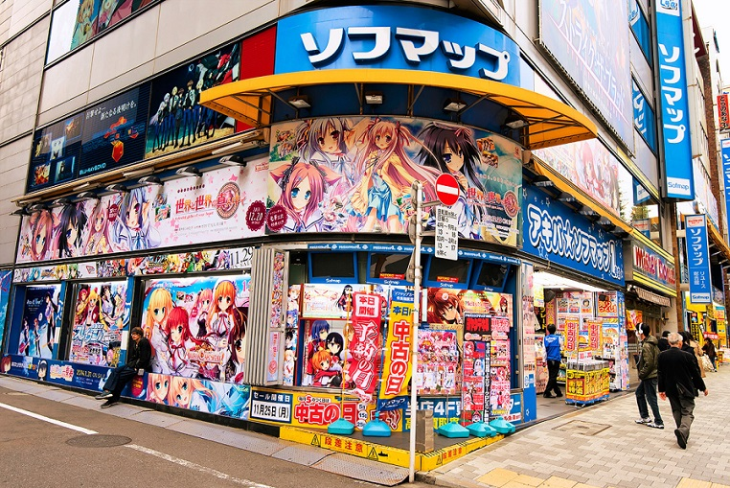

Figure 1: Images I saw online that heavily influenced my idea of Japan before I arrived.
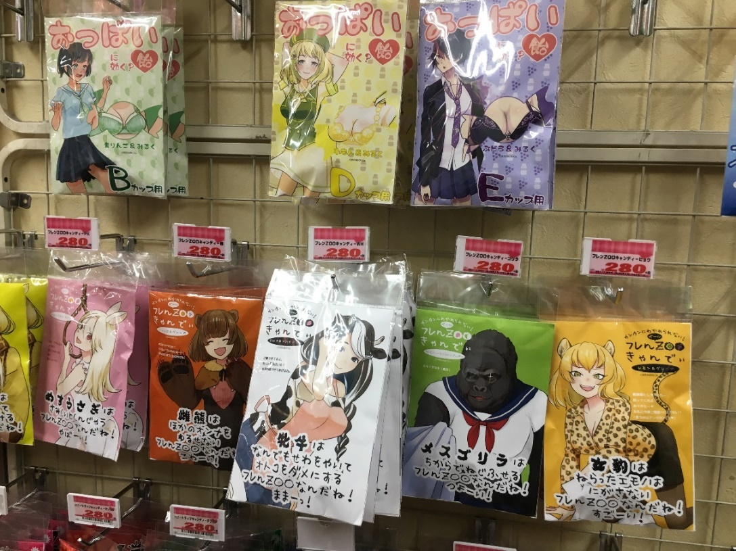
Figure 2: Erotic advertisements with some anime women on them, advertising candy.
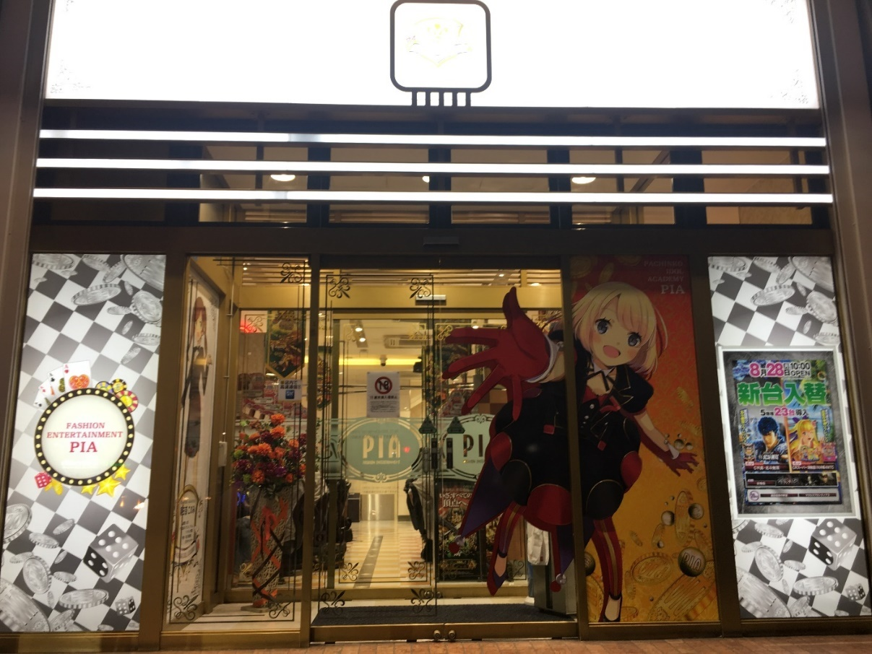
Figure 3: Alluring anime figure for a Pachinko site.

Although there were a couple really giant anime franchises, like Animate, that I was able to stumble upon on my own, most of my research occurred after I followed a friend who had been exploring the anime community for months in Japan already. After exploring both the large and small places, it can safely be claimed that most of the more genuine anime shops are highly concealed in small, underground corners. Due to the narrow stairways down, and tiny entrances without many signs pointing it out (and none in English), I would never have thought to go into the shops if I was not led in (see Figure 4 & 5). These kinds of settings really speak to the type of fans that are prevalent in Japan: most of these shops would not be stumbled upon on accident, but you would have to be highly involved in the fandom and actively seek out the place. In addition, this clearly distinguishes between the two types of shops: the larger ones are more general, and include numerous varieties of anime; unsurprisingly, there were some foreigners inside. However, the smaller shops, many secondhand, were highly specific, and often times catered only to fans of a few choice anime. I do not remember there being any foreigners (besides my friends and me) inside those shops. Furthermore, the types of merchandise available at these specific shops were more collector-friendly, and contained many cases of limited edition products. There were buckets of pins and shelves of figurines even (and especially) with characters that usually would not have been found at the giant anime corporations (see Figure 6 & 7).

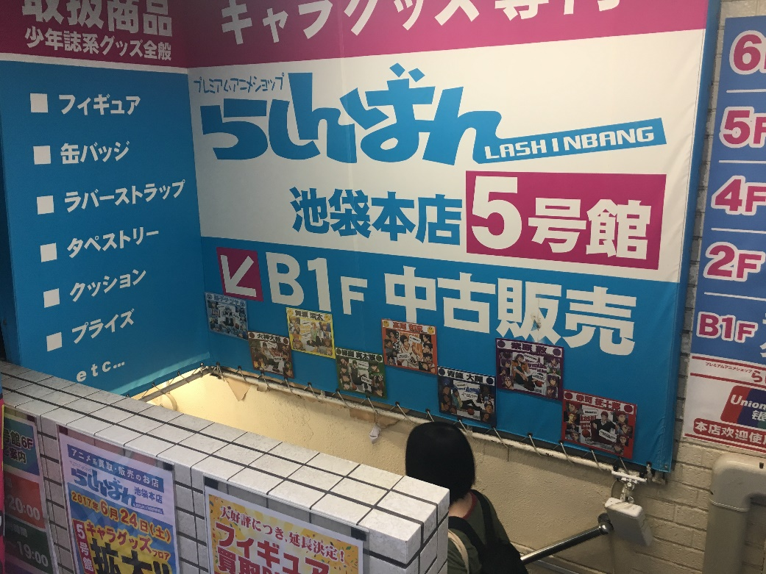
Figure 4: Entryways into smaller shops that would easily be overlooked by people not dedicated to finding them.
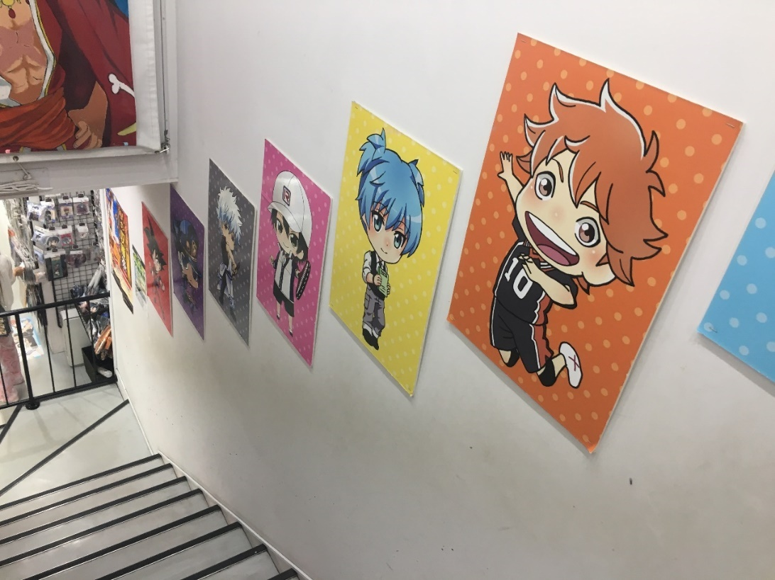
Figure 5: Any trace of anime could only be seen upon entry down into the shop.
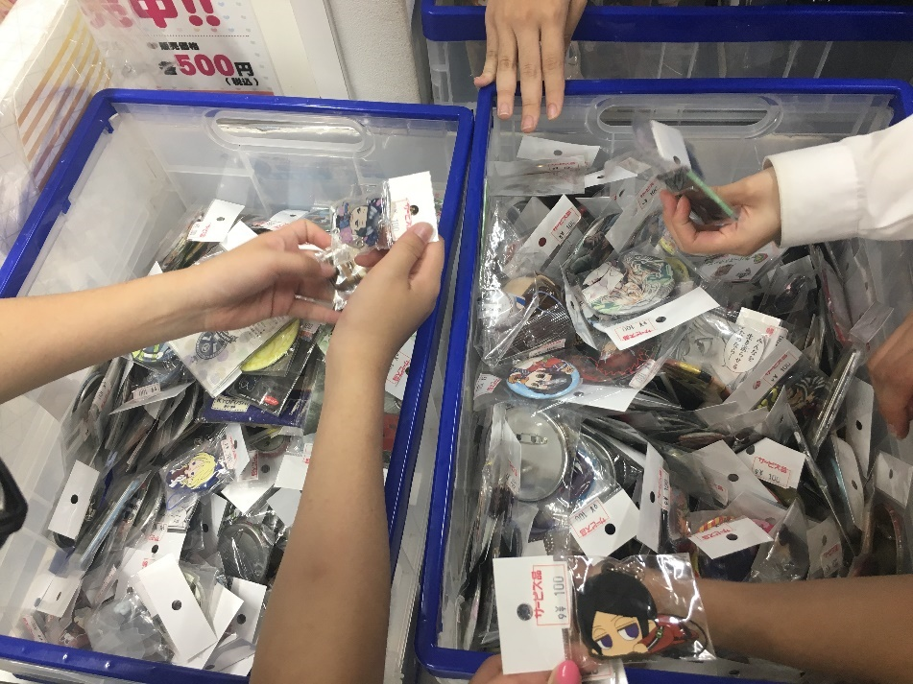
Figure 6: Buckets of various pins with many sub-characters that bigger anime corporations do not have.
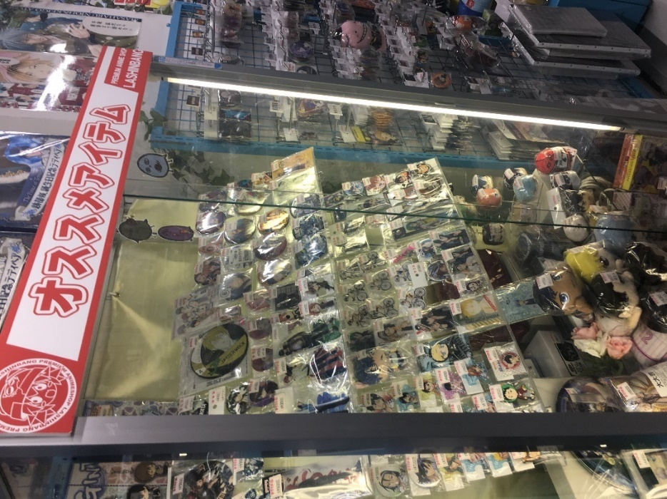
Figure 7: Shelves of collectible pins, figures, and key rings.
Besides shops selling anime merchandise, I came across a couple cafes and restaurants that were themed for a certain anime. One such café focused entirely on one fairly new anime that I had barely heard of, called “Dive!!” (see Figure 8). After doing some research on this anime, I found out that it is extremely new, and was still airing when I discovered the café dedicated to it. In fact, it only finished airing on 9/22/17, which means that when I encountered it at the beginning of September, it would not have been well-known, especially not outside of Japan (since subbed and dubbed versions usually take at least a few weeks to come out internationally). To have a café like this means that there must be a fairly big, but tight, community that is not for newbies to the anime fandom, and that outsiders like me would not even know about. Similarly, I came across “Yuri! On Ice” cookies at a local Lawson convenience store (see Figure 9). Due to the overpriced aspect of these cookies, though, it is clear that people would only purchase them if they are a fan of the anime “Yuri! On Ice” rather than for the actual cookies. Therefore, based on these observations, I argue that Japan’s anime fan culture is not as mainstream as is usually depicted in the United States. Moreover, the fandoms in Japan are heavily centered in small niches, as made evident by the small, specific merchandise stores and the themed cafes for small communities of fans.
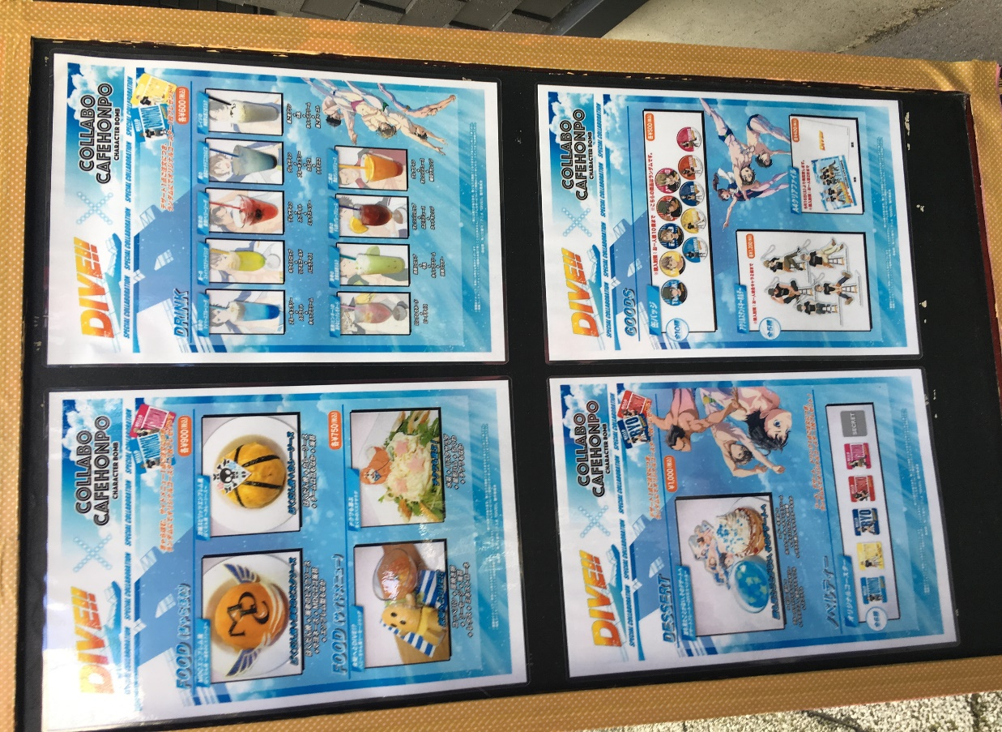

Figure 8: "Dive!!" cafe with various themed foods and drinks, for avid fans.
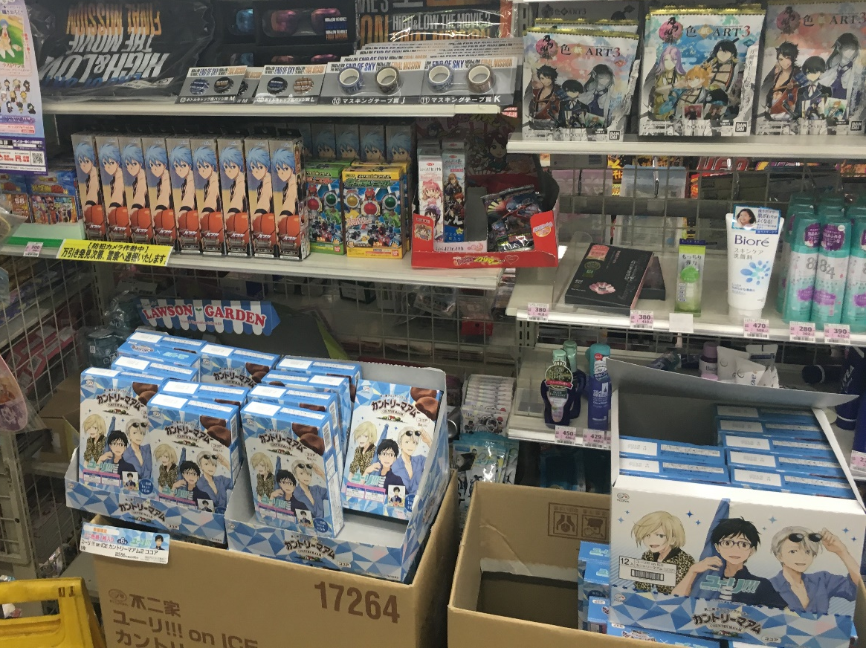

Figure 9: "Yuri! On Ice" cookies, and various other specific merchandise in Lawson; convenient for fans to stop by and pick up.

In contrast to Japan’s concentrated, niche fandoms, from my experience in the United States, people usually say that they are a “fan of anime” instead of a fan of a specific anime. The few stores here with anime merch, like Hot Topic, for example, are extremely broad, and only carry basic merchandise for a few extremely mainstream anime. That being said, it is clear that in the United States, fandoms are more open, and it seems like it would be easier to become interested in anime and slowly ease into the fandoms, whereas Japanese fandoms are more exclusive. As to why this is, I have a theory that it is due to the exposure of people to anime. In their article The History of Manga and Anime, Marwah Zagzoug writes,
The major difference between anime and American cartoons is that unlike Americans cartoons, which are only watched by children, anime is popular among the Japanese adults and is watched by millions. The audience is not merely directed to children but to teens and adults as well.
It appears that in Japan, anime is made for a wider range of audiences, but children are exposed to it early on, which makes sense since anime is broadcast so frequently on TV, and as Williams claimed, “nearly 50% of all films made in Japan are animated” (55). On the other hand, Americans like myself are usually exposed to anime later, typically after being introduced to it by a friend or someone who is already familiar with the anime culture. It does not seem as likely that an American will stumble into anime on TV or the Internet, since it’s still not that widely spread. Thus, by the time a person reaches their teen years, which is the age group that most my research has been conducted on, Japanese people will have already either grown into, or grown completely out of anime. They will have joined their specific niche already, or left anime. However, at this point, an American would have only just recently been introduced to anime; they will jump around with mainstream anime, and likely will not settle into one fandom completely. Since fandoms and resulting anime businesses usually cater to their fans, there emerge different types of merchandise stores and different dynamics in fan culture in Japan and the United States.
In conclusion, in the three weeks that I have done initial research in Japan, I’ve found that anime is not as mainstream as I had thought. There was only one instance where what I saw matched what I expected (see Figure 10). Not only is it not mainstream, but the few anime communities that I did encounter were extremely specific; perhaps if I had grown up in Japan, or was fluent in Japanese, I may have seen more anime-related things that I simply overlooked this time. In any case, because what I saw differed so greatly from my expectations, I was shocked, and felt almost as if the images I had seen in the United States had betrayed me. Why had I been so naïve, or so susceptible to those pictures?
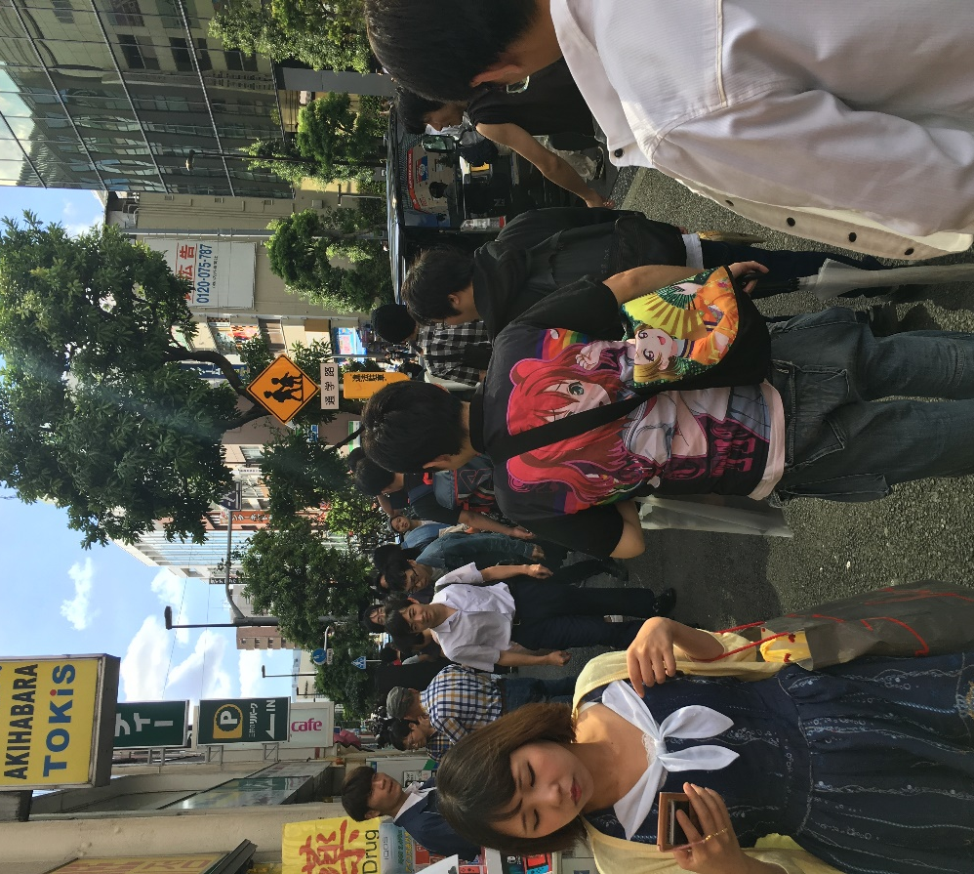
Figure 10: The only stereotypical 'otaku' that I saw on the streets in 3 weeks.
Now, it would be interesting to look into whether the Japanese government is intentionally playing a role in promoting its anime. Also, what kind of image is the United States promoting for itself? Or rather, how does Japan and other countries view the U.S? As international communication becomes more crucial, the image that each country gives of itself is also very important, and has potential to greatly influence the national identity of people in each country. To end on a quote by Miyazaki Hayao, creator of one of the most renown anime studios in the 21st century, he says, “I do believe in the power of story. I believe that stories have an important role to play in the formation of human beings, that they can stimulate, amaze and inspire their listeners”. I agree, and it will be interesting to see whether anime becomes a bigger part of Japanese youths’ identity, and how anime’s potential may be utilized.

Works Cited
Cooper, Lisa Marie. "The History of Anime." Right Stuf Anime. N.p., n.d. Web.
McGray, Douglas. "Japan’s Gross National Cool." Foreign Policy. N.p., 11 Nov. 2009. Web. 22 Sept. 2017.
Mckevitt, Andrew C. "“You Are Not Alone!”: Anime and the Globalizing of America." Diplomatic History 34.5 (2010): 893-921. Wiley Online Library. Web. 22 Sept. 2017.
Williams, Kara Lenore. The Impact of Popular Culture Fandom on Perceptions of Japanese Language and Culture Learning: The Case of Student Anime Fans. Diss. The U of Texas at Austin, 2006. N.p.: n.p., n.d. University of Washington Libraries. Web. 22 Sept. 2017.
Yoshio Sugimoto, “Nation and Nationalism in Contemporary Japan,” Sage Handbook of Nations and Nationalism (2006), Pp. 1-487.
Zagzoug, Marwah. "The History of Anime and Manga." Nova Online. N.p., 2001. Web.

